Movie Revenue

Ye In Jeon

George Washington University

Contact: yein429@gwu.edu

**Abstract**

With the continuing expansion of the movie industry, increasing movie revenue is of increasing importance. To maximize movie revenue, it is useful to analyze the factors that affect it. In this paper, the influences of release month and budget on movie revenue are examined. The release months with higher and lower movie revenue compared to other periods. Moreover, it examines the correlation between the budgets of the movies and movie revenue. The analysis is made based on the dataset from Kaggle, initially from ‘The Movie Database’ API. It includes 350,000 movies from the end of 19th century to August 2017, with associated variables.

*Keywords*: Movie, Film, Movie Revenue

**Introduction**

The number of the movies released has been increasing globally over recent years in different countries. This indicates that the movie industry is expanding every year. For instance, “[m]ovie releases at theaters generated approximately US$9 billion in revenue in 2005, representing a nearly 20% increase since the beginning of the decade” (Somlo, Rajaram, & Ahmadi 2011). Lieberman (2006) asserts that the movie industry is now in the peculiar situation of being one of the most visible industries to the people in the U.S. With the growth of the movie industry and the increasing attention it is drawing, “there are numerous studies on various aspects of the movie industry” (Luo 2014).

Since “[f]ilm is a high-risk cultural industry,” many people consider predicting movie revenue an important factor among the many affecting decision-making in the movie industry (Liu, Xiao, Yiheng, Haochen, & Maosheng, 2016). In particular, investors in the movie industry consider the estimated revenue when they make decisions. Therefore, it is meaningful to analyze the factors that affect movie revenues so that they can be controlled and the revenues maximized. Instead of a comprehensive analysis of the elements that can affect movie revenues, this paper only analyzes the influence of the release month and the budget on movie revenues. The analysis is made based on movies from all over the world, regardless of the genres and the languages spoken in the movies.

**Literature Review**

There are many studies related to movie revenues. Palia, Ravid, and Reisel (2008) mention that movie revenues are often used as a dependent variable because the movie industry often focuses on revenues. Some researchers have examined the different factors that may affect movie revenues. The opinions of the audience have been considered in the literature. Moon, Bergey, and Iacobucci (2010) find that ratings are associated with movie revenues, with high ratings contributing to enhanced revenues. “One unit [of rating] increase is associated with about 28% increase in revenue” (Zimbra, Sarangee, & Jindal 2017). The “reviews by a top reviewer displayed in the ad are the most significant factor determining movie revenues” (Rao, Abraham, Gretz, Chen, & Basuroy 2017). Social media and movie revenue prediction has drawn much attention from both the movie industry and academia (Lu, Wang, & Maciejewski 2014). Liu, Xiao, Yiheng, Haochen, and Maosheng (2016) found a strong correlation between the purchase intention for movies as expressed in social media and movie revenues. Zimbra, Sarangee, and Jindal (2017) found that “an increase of one unit (i.e., one thousand tweets) in daily tweets on iOS is associated with [an] almost 8% increase in revenue next day during the first ten days of release.”

Moreover, the effect of the famous actors’ presence toward the movie revenues has been examined. Joshi (2015) finds that stars may not guarantee profits, though their presence results in lower weekly revenue volatility. There was “an increase of 75% in revenue [in a movie with star power] over a movie without star power” (Zimbra, Sarangee, & Jindal, 2017). Nelson and Glotfelty (2012) stress the importance of the relationship between star power and box office revenues in other countries. “The results indicate that replacing an average star with a top star would increase revenues by an average of $16,618,570, while replacing three average stars with three top stars would increase revenues by an average of $64,410,381” (Nelson & Glotfelty, 2012).

Other factors have been observed to have a relationship with revenue. Zimbra, Sarangee, and Jindal (2017) found a positive association with daily revenue during the first ten days and the number of theaters, with each additional theater associated with an approximately 1.4% increase in revenue. In addition, the impact of R-rating on movie revenues has been found to be statistically significant. “[T]hose that actually receive an R-rating end up receiving about 20% less in domestic revenues” (Palsson, Price, & Shores 2013). Furthermore, the relationship between budgets and the movie revenues has been addressed in the literature. Bi and Giles (2009) found that among 360 blockbusters with gross box office income of over $100 million during their theatrical runs, 290 (about 80%) had budgets above $60 million. Thus, “[i]n most cases, the distribution of box office revenue is dominated by these high budget movies.” (Bi & Giles 2009). Moreover, Peukert, Claussen and Kretschmer (2017) state the importance of the information externality to the movie revenues. For instance, “[l]arge blockbusters (i.e., wide-release movies) may be able to compensate with large advertising budgets, while word-of-mouth is likely to matter more for movies targeted at smaller audiences (Peukert, Claussen & Kretschmer 2017). According to Shon, Kim, and Yim (2014), “based on a set of distinct movie characteristics as perceived by the movie audience values, movies [can be classified] into categories called movie type [which is similar to movie genre].” They found that movie types affect three box-office performance categories (opening week revenue, total revenue, and revenue per-screen).

hose that actually receive an R-rating

end up receiving about 20% less in domestic

revenues and are about 10 percentage points

more likely to have their revenues fall short

of their budget.

hose that actually receive an R-rating

end up receiving about 20% less in domestic

revenues and are about 10 percentage points

more likely to have their revenues fall short

of their budget.

hose that actually receive an R-rating

end up receiving about 20% less in domestic

revenues and are about 10 percentage points

more likely to have their revenues fall short

of their budget.

**Data and Dataset**

The data used for the analysis is derived from the Kaggle website, which is originally from ‘The Movie Database’ API. It contains more than 350,000 movies from all over the world, starting from end of the 19th century to August 2017. The dataset includes data on various variables related to the movies, such as budget, genre, title, production company, production country, release date, revenue, and so on.

To ensure that the present research (while drawing on a sufficient depth of data to ensure validity of conclusions) identifies trends that reflect current conditions, the period of the analysis is limited to from 2008 to 2017. In addition, among the numerous variables in the dataset, the present study analyzes the effects of the budget and release date on revenue. The revenue is data collected from all countries globally but is given in US Dollars. The budget data is also given in US Dollars. The release date is converted to release month for better categorization and to increase the effectiveness of the analysis. Using release day would be too specific and detailed for the grouped analysis. Moreover, the year value is also eliminated, because it is obvious that the total movie revenue increases through time at that scale due to various elements, such as the expansion of the movie industry and the increased number of consumers. In addition, the movies with 0 value of budget and revenue are eliminated. When drawing the plots, some movie variables are excluded to exclude the outliers from the analysis for better data visualizations.

**Key Findings**

The present paper analyzes how the movie revenue changes upon the budget and the release month. First, the influence of the release month on revenue is examined to determine the best month to release the movie to maximize revenue.

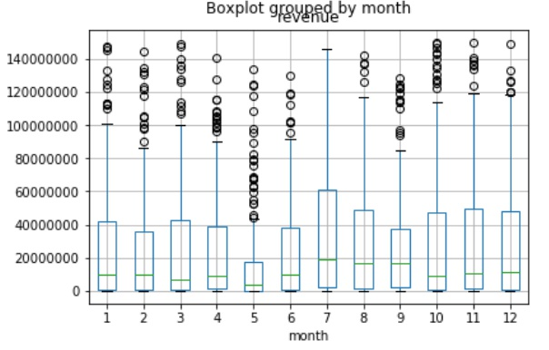

Figure 2

The movies released in July showed the highest median and third quartile (Figure 2). In other words, 50% of the movies released on July showed higher revenue than the movies released in other months (Figure 2). Furthermore, the third quartile and the median are lowest in May (Figure 2). This indicates that half of the movies released in May have relatively lower revenue than movies released in other months (Figure 2).

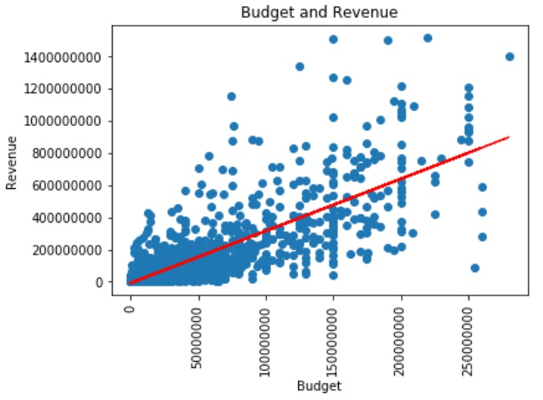

Figure 3

The linear line and the distribution of the scatter plot show that the budget of the movies positively affects the revenue of the movies (Figure 3). Moreover, the positive relationship between the budget and the revenue of movies can be proven in Pearson method correlation test. The result of the correlation test between the revenue and the budget is 0.81, which means the two variables are highly and positively correlated.

To sum up, the movies released in July tend to show higher revenue compared to other months. On the other hand, movie released on May tend to have lower revenue than those released in other months. In addition, there is high possibility that a higher budget of a movie will result in higher revenue with the correlation coefficient 0.81.

**Recommendations**

Based on the above analysis, recommendations can be made for decision-makers related to the movie industry, such as investors. In the process of planning the film production, they can consider the release period and budget to enhance their revenue. According to the result, it is recommended to release in July and have high budgets to increase revenue.

Researchers interested in the movie industry, can develop and expand the present analysis. For instance, they can analyze which genres produce the highest and lowest revenue in July and May. In addition, there can be additional analysis about the effect of the budget on the revenue according to genre. Furthermore, in future studies, the researchers can find other factors affecting the revenue of the movies to create a meaningful prediction formula.

**Conclusions**

With the continuing expansion of the movie industry, the interest in movie revenues and the factors affecting them is increasing every year. Therefore, in this paper, the influence of the release month and the budgets on the movie revenues is analyzed. According to the findings, the movies released in July tend to show higher revenue, while the movies released in May tend to have lower revenue. Furthermore, the higher budget tends to result in higher revenue. Thus, release month and budget are factors that investors and film production companies should consider during their decision-making processes. Future studies on other factors could contribute to development of the movie industry by enhancing the revenues of the movies.

**Biography**

Ye In Jeon, the writer of this paper, earned a Bachelor of Science in Statistics and is pursuing a Master of Science in Data Science from George Washington University.

Dr. Nima Zahadat, instructing the Data Mining course at George Washington University in spring semester of 2018, is a professor of data science, information systems security, and digital forensics.

References

Bi, G., & Giles, D. E. (2009). Modelling the financial risk associated with U.S. movie box office earnings. *Mathematics and Computers in Simulation*, *79*(9), 2759–2766.

Joshi, A. (2015). Movie stars and the volatility of movie revenues. *Journal of Media Economics*, *28*(4), 246–267.

Lieberman, E. (2006). Hollywood economics: How extreme uncertainty shapes the film industry. *Film Quarterly*, *59*(3), 74–75.

Liu, T., Xiao D., Yiheng C., Haochen C., & Maosheng G. (2016). Predicting movie box-office revenues by exploiting large-scale social media content. *Multimedia Tools and Applications*, *75*(3) (02): 1509–1528,

Lu, Y., Wang, F., & Maciejewski, R. (2014). *Business Intelligence from Social Media: A Study from the VAST Box Office Challenge*. *Los* Alamitos: IEEE.

Luo, H. (2014). When to sell your idea: Theory and evidence from the movie industry. *Management Science*, *60*(12), 3067–3086.

Moon, S., Bergey, P. K., & Iacobucci, D. (2010). Dynamic effects among movie ratings, movie revenues, and viewer satisfaction. *Journal of Marketing*, *74*(1), 108–121.

Nelson, R. A., & Glotfelty, R. (2012). Movie stars and box office revenues: An empirical analysis. *Journal of Cultural Economics*, *36*(2), 141–166.

Palia, D., Ravid, S., & Reisel, N. (2008). Choosing to cofinance: Analysis of project-specific alliances in the movie industry. *The Review of Financial Studies*, *21*(2), 483–511.

Palsson, C., Price, J., & Shores, J. (2013). Ratings and revenues: Evidence from movie ratings. *Contemporary Economic Policy*, *31*(1), 13–21.

Peukert, C., Claussen, J., & Kretschmer, T. (2017). Piracy and box office movie revenues: Evidence from megaupload. *International Journal of Industrial Organization*, *52*, 188–215.

Rao, V. R., Abraham (Avri) Ravid, S., Gretz, R. T., Chen, J., & Basuroy, S. (2017). The impact of advertising content on movie revenues. *Marketing Letters*, *28*(3), 341–355.

Shon, J., Kim, Y., & Yim, S. (2014). Classifying movies based on audience perceptions: MTI framework and box office performance. *Journal of Media Economics*, *27*(2), 79–106.

Somlo, B., Rajaram, K., & Ahmadi, R. (2011). Distribution planning to optimize profits in the motion picture industry. *Production and Operations Management*, *20*(4), 618–IX.

Zimbra, D., Sarangee, K. R., & Jindal, R. P. (2017). Movie aspects, tweet metrics, and movie revenues: The influence of iOS vs. Android. *Decision Support Systems*, *102*, 98–109.